Equipment Master Data ODATA Documentation, 24.10.2018

MST, 30.10.: Corrected URL

Mst, 09.11.: Added fields for material and customer short descriptions

DSc 23/5/19: Changed fields & JSON output

MSt: 29.05.: Corrected Urls

Structure of OData Service:

|  |  |  |  |  |
| --- | --- | --- | --- | --- |
| **Component** | **Data Type** | **Length** | **Decimals** | **Description** |
| EQUNR | CHAR | 18 | 0 | Equipment Number |
| MATNR | CHAR | 18 | 0 | Material Number |
| MAKTX |  |  |  | Material Description (Short Text) |
| SERNR | CHAR | 18 | 0 | Serial Number |
| KUNDE | CHAR | 10 | 0 | Customer to Whom Serial Number was Delivered |
| NAME1 | CHAR | 35 | 0 | Customer name |
| DATAB | DATS | 8 | 0 | Valid-From Date |
| DATBI | DATS | 8 | 0 | Valid To Date |
| YYBAU | CHAR | 3 | 0 | Engine series |
| YYERZ | CHAR | 18 | 0 | Product Type |
| VKBUR | CHAR | 4 | 0 | Sales Office |
| EQART | CHAR | 10 | 0 | Type of Equipment |
| T_PARTNER |  |  |  | Table of partners |

Structure of partner data:

|  |  |  |  |  |
| --- | --- | --- | --- | --- |
| **Component** | **Data Type** | **Length** | **Decimals** | **Description** |
| EQUNR | CHAR | 18 | 0 | Equipment Number |
| PARVW | CHAR | 2 | 0 | Partner Function |
| PARNR | CHAR | 12 | 0 | Partner number |
| NAME1 | CHAR | 35 | 0 | Partner name |

Get Test Data:

Request entity with serial number of aggregate:

https://sap-fes-i.org-intra.net/sap/opu/odata/sap/Y_DIGITAL_TWIN_SRV/EQUI01Set?$filter=Sernr eq 'SER-00123'&$format=json

Request entity with serial number of engine:

https://sap-fes-i.org-intra.net/sap/opu/odata/sap/Y_DIGITAL_TWIN_SRV/EQUI01Set?$filter=Sernr eq '4711-001'&$format=json

* Both requests will result in same data since backend function will recognize which serial number belongs to aggregate or engine ! (You could even call the service with … EQUI01Set?$filter=SernrEng eq ‘SER-00123’ and it would give you the same correct result)

Request with expanded partner list:

https://sap-fes-i.org-intra.net/sap/opu/odata/sap/Y_DIGITAL_TWIN_SRV/EQUI01Set?$filter=Sernr eq '4711-001'&$expand=EquiPartSet&$format=json

Test Data in SAP Backend:

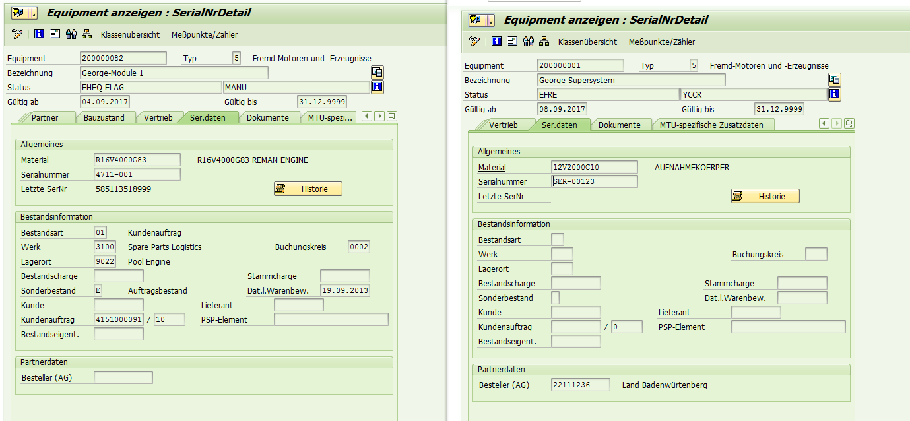

Serial number engine: 4711-001

Serial number aggregate: SER-00123

Test Data in Json:

{  
  "d" : {  
    "results" : [  
      {  
        "__metadata" : {  
          "id" : "https://sap-fes-i.org-intra.net/sap/opu/odata/sap/Y_DIGITAL_TWIN_SRV/EQUI01Set('000000000200000082')",  
          "uri" : "https://sap-fes-i.org-intra.net/sap/opu/odata/sap/Y_DIGITAL_TWIN_SRV/EQUI01Set('000000000200000082')",  
          "type" : "Y_DIGITAL_TWIN_SRV.EQUI01"  
        },  
        "Equnr" : "000000000200000082",  
        "Matnr" : "R16V4000G83",  
        "Maktx" : "R16V4000G83 REMAN ENGINE",  
        "Sernr" : "4711-001",  
        "Kunde" : "0022111236",  
        "Name1" : "Land Badenwürtenberg",  
        "Datab" : "2017-09-08",  
        "Datbi" : "9999-12-31",  
        "Yybau" : "030",  
        "Yyerz" : "10V1600A50",  
        "Vkbur" : "0101",  
        "Eqart" : "SYS",  
        "EquiPartSet" : {  
          "__deferred" : {  
            "uri" : "https://sap-fes-i.org-intra.net/sap/opu/odata/sap/Y_DIGITAL_TWIN_SRV/EQUI01Set('000000000200000082')/EquiPartSet"  
          }  
        }  
      }  
    ]  
  }  
}

JSON data for partner list:

{  
  "d" : {  
    "results" : [  
      {  
        "__metadata" : {  
          "id" : "https://sap-fes-i.org-intra.net/sap/opu/odata/sap/Y_DIGITAL_TWIN_SRV/EQUI01Set('000000000200000082')",  
          "uri" : "https://sap-fes-i.org-intra.net/sap/opu/odata/sap/Y_DIGITAL_TWIN_SRV/EQUI01Set('000000000200000082')",  
          "type" : "Y_DIGITAL_TWIN_SRV.EQUI01"  
        },  
        "Equnr" : "000000000200000082",  
        "Matnr" : "R16V4000G83",  
        "Maktx" : "R16V4000G83 REMAN ENGINE",  
        "Sernr" : "4711-001",  
        "Kunde" : "0022111236",  
        "Name1" : "Land Badenwürtenberg",  
        "Datab" : "2017-09-08",  
        "Datbi" : "9999-12-31",  
        "Yybau" : "030",  
        "Yyerz" : "10V1600A50",  
        "Vkbur" : "0101",  
        "Eqart" : "SYS",  
        "EquiPartSet" : {  
          "results" : [  
            {  
              "__metadata" : {  
                "id" : "https://sap-fes-i.org-intra.net/sap/opu/odata/sap/Y_DIGITAL_TWIN_SRV/EquiPartSet('000000000200000081')",  
                "uri" : "https://sap-fes-i.org-intra.net/sap/opu/odata/sap/Y_DIGITAL_TWIN_SRV/EquiPartSet('000000000200000081')",  
                "type" : "Y_DIGITAL_TWIN_SRV.EquiPart"  
              },  
              "Equnr" : "000000000200000081",  
              "Parvw" : "EN",  
              "Parnr" : "0021001845",  
              "Name1" : "MTU Asia Pte. Ltd."  
            },  
            {  
              "__metadata" : {  
                "id" : "https://sap-fes-i.org-intra.net/sap/opu/odata/sap/Y_DIGITAL_TWIN_SRV/EquiPartSet('000000000200000081')",  
                "uri" : "https://sap-fes-i.org-intra.net/sap/opu/odata/sap/Y_DIGITAL_TWIN_SRV/EquiPartSet('000000000200000081')",  
                "type" : "Y_DIGITAL_TWIN_SRV.EquiPart"  
              },  
              "Equnr" : "000000000200000081",  
              "Parvw" : "YL",  
              "Parnr" : "0021001845",  
              "Name1" : "MTU Asia Pte. Ltd."  
            },  
            {  
              "__metadata" : {  
                "id" : "https://sap-fes-i.org-intra.net/sap/opu/odata/sap/Y_DIGITAL_TWIN_SRV/EquiPartSet('000000000200000081')",  
                "uri" : "https://sap-fes-i.org-intra.net/sap/opu/odata/sap/Y_DIGITAL_TWIN_SRV/EquiPartSet('000000000200000081')",  
                "type" : "Y_DIGITAL_TWIN_SRV.EquiPart"  
              },  
              "Equnr" : "000000000200000081",  
              "Parvw" : "WE",  
              "Parnr" : "0021017657",  
              "Name1" : "Valley Power Systems, Inc."  
            },  
            {  
              "__metadata" : {  
                "id" : "https://sap-fes-i.org-intra.net/sap/opu/odata/sap/Y_DIGITAL_TWIN_SRV/EquiPartSet('000000000200000081')",  
                "uri" : "https://sap-fes-i.org-intra.net/sap/opu/odata/sap/Y_DIGITAL_TWIN_SRV/EquiPartSet('000000000200000081')",  
                "type" : "Y_DIGITAL_TWIN_SRV.EquiPart"  
              },  
              "Equnr" : "000000000200000081",  
              "Parvw" : "RG",  
              "Parnr" : "0022000006",  
              "Name1" : "MTU ASIA PTE LTD (Name)1"  
            },  
            {  
              "__metadata" : {  
                "id" : "https://sap-fes-i.org-intra.net/sap/opu/odata/sap/Y_DIGITAL_TWIN_SRV/EquiPartSet('000000000200000081')",  
                "uri" : "https://sap-fes-i.org-intra.net/sap/opu/odata/sap/Y_DIGITAL_TWIN_SRV/EquiPartSet('000000000200000081')",  
                "type" : "Y_DIGITAL_TWIN_SRV.EquiPart"  
              },  
              "Equnr" : "000000000200000081",  
              "Parvw" : "AG",  
              "Parnr" : "0022000815",  
              "Name1" : "Verkehrs - Industrie - System GmbH"  
            },  
            {  
              "__metadata" : {  
                "id" : "https://sap-fes-i.org-intra.net/sap/opu/odata/sap/Y_DIGITAL_TWIN_SRV/EquiPartSet('000000000200000081')",  
                "uri" : "https://sap-fes-i.org-intra.net/sap/opu/odata/sap/Y_DIGITAL_TWIN_SRV/EquiPartSet('000000000200000081')",  
                "type" : "Y_DIGITAL_TWIN_SRV.EquiPart"  
              },  
              "Equnr" : "000000000200000081",  
              "Parvw" : "RE",  
              "Parnr" : "0022000816",  
              "Name1" : "Burgmayr Engines GmbH"  
            },  
            {  
              "__metadata" : {  
                "id" : "https://sap-fes-i.org-intra.net/sap/opu/odata/sap/Y_DIGITAL_TWIN_SRV/EquiPartSet('000000000200000081')",  
                "uri" : "https://sap-fes-i.org-intra.net/sap/opu/odata/sap/Y_DIGITAL_TWIN_SRV/EquiPartSet('000000000200000081')",  
                "type" : "Y_DIGITAL_TWIN_SRV.EquiPart"  
              },  
              "Equnr" : "000000000200000081",  
              "Parvw" : "YB",  
              "Parnr" : "0022000816",  
              "Name1" : "Burgmayr Engines GmbH"  
            },  
            {  
              "__metadata" : {  
                "id" : "https://sap-fes-i.org-intra.net/sap/opu/odata/sap/Y_DIGITAL_TWIN_SRV/EquiPartSet('000000000200000081')",  
                "uri" : "https://sap-fes-i.org-intra.net/sap/opu/odata/sap/Y_DIGITAL_TWIN_SRV/EquiPartSet('000000000200000081')",  
                "type" : "Y_DIGITAL_TWIN_SRV.EquiPart"  
              },  
              "Equnr" : "000000000200000081",  
              "Parvw" : "YR",  
              "Parnr" : "0022111236",  
              "Name1" : "Land Badenwürtenberg"  
            },  
            {  
              "__metadata" : {  
                "id" : "https://sap-fes-i.org-intra.net/sap/opu/odata/sap/Y_DIGITAL_TWIN_SRV/EquiPartSet('000000000200000081')",  
                "uri" : "https://sap-fes-i.org-intra.net/sap/opu/odata/sap/Y_DIGITAL_TWIN_SRV/EquiPartSet('000000000200000081')",  
                "type" : "Y_DIGITAL_TWIN_SRV.EquiPart"  
              },  
              "Equnr" : "000000000200000081",  
              "Parvw" : "ZL",  
              "Parnr" : "0022111236",  
              "Name1" : "Land Badenwürtenberg"  
            }  
          ]  
        }  
      }  
    ]  
  }  
}